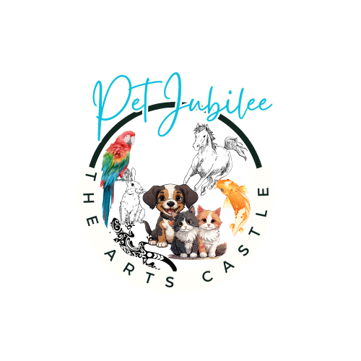

Pet Jubilee
Juried Art Exhibit @ The Arts Castle
October 21, 2024-January 10, 2025
Call for Entries

Eligibility:
- Open to Residents of Central Ohio. This is a juried art show Showcasing the fur, feathered, hoofed and fin.
- You may enter up to three pieces of your original artwork created within the last 3 years. Please do not enter artwork that was exhibited at The Arts Castle in the past 3 years.
- 2D Categories: Painting, Drawing, Photography, Computer Art, Mixed Media.
- 3D Categories: Ceramics, Sculpture, Jewelry, Fiber, Metal/Wood/Glass/Stone.
Awards will be given to the top three placings in both categories as well as the BEST OF SHOW.
Sale of Art Works:
The Arts Castle will collect payments from clients for art work sold during the exhibit. The Arts Castle will retain 40% of the price of the work and will remit the remainder to the artist 10-14 business days following the close of the exhibit.
Insurance: The Arts Castle will carry “property of others” insurance on items received through the day of pick-up on Jan 12, 2025. However, The Arts Castle is not liable for loss or damage of exhibit items and/or owner property. Any loss, damage or theft not covered by insurance will be completely borne by the owner/artist.
Entries:
- ALL ENTRIES MUST BE RECEIVED BY 5pm ON Wednesday, September 25, 2024.
- Entry Fee: $10 to enter. PLEASE INCLUDE PAYMENT WITH ENTRY FORM.
Send your completed entry form, entrance fee and images of up to three original art works by
- Email the form to petjubilee.artscastle@gmail.com and post payment at http://hisawyer.com/the-arts-castle/schedules/activity-set/997435
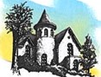
By mail: send entry & photographs 4x6 or larger to: (please include artists name, medium, title on the back of each piece)
The Arts Castle Attn: Pet Jubilee 190 W. Winter Street Delaware, Ohio 43015

Size and weight: If a work of art weighs more than 50 pounds, or is larger than 36”x48”, including the frame, or if you have questions, please contact Paula Blosser at petjubilee.artscastle@gmail.com
PLEASE DO NOT SUBMIT YOUR ART WORK UNTIL YOU HAVE BEEN NOTIFIED THAT IT HAS BEEN ACCEPTED AFTER THE JURYING PROCESS. If accepted please label each piece on the back.
Image use
I hereby authorize The Arts Castle to use, re-use, and/or disclose, without compensation to me, images of any works exhibited for Senior Showcase purposes, including publicity, marketing, and advertising.
I understand that The Arts Castle may use this in various media, including but not limited to mailings,
brochures, television, video, film, emails, and on social media. I further understand that such use may
cause my image to appear in newspaper articles or television, radio or internet news stories. I waive any right to approve any material in which The Arts Castle may eventually use this image. I hereby release The Arts Castle from any and all liability related to or resulting from the use and dissemination of this image. I understand that my agreement to this authorization and release is voluntary.

CHECKLIST FOR ENTRY
Did you include?
_____ Entry fee ($10 to enter)
_____ Photo of art work
_____ Entry Form /Exhibitor Agreement
_____ Piece descriptions
ALL ENTRIES MUST BE RECEIVED BY 5 p.m. ON Wednesday, September 25, 2024. Via email or postal mail.
PLEASE DO NOT DROP-OFF YOUR ART WORK UNTIL YOU HAVE BEEN NOTIFIED THAT IT HAS BEEN ACCEPTED AFTER THE JURYING PROCESS
Important Dates:
- ALL ENTRIES MUST BE RECEIVED BY 5 p.m. ON Wednesday, September 25, 2024.
  - Those accepted to participate will be notified by email on September 27, 2024
  - Drop off: Oct 13, 2024, 2:00-4:00pm.
  - Reception: October 27, 2024, 3-5:00pm at The Arts Castle.
  - Pet Jubilee Exhibit will be on display Oct 21, 2024-Jan 10, 2025 at The Arts Castle, M-F, 9-5 pm.

For questions, contact Paula Blosser at petjubilee.artscastle@gmail.com
PLEASE KEEP THIS COPY FOR YOUR RECORDS. Turn in a copy of the third page as your entry form and include it with payment.
Payment accepted by check, in person or by mail, or online

Pet Jubilee Exhibit Entries 2024
Name____________________________________
Phone______________________
Address___________________________________
______________________________________
Email_____________________________________

Signature:____________________________________
By signing this document, you agree to the terms/rules of this exhibit.

- Title:_______________________________________________
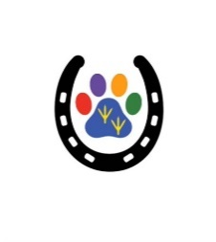
Medium:____________________________________________
Artist:_______________________________________________
Price/NFS____________________________________________

- Title:_______________________________________________
Medium:____________________________________________
Artist:_______________________________________________
Price/NFS____________________________________________

- Title:_______________________________________________
Medium:____________________________________________
Artist:_______________________________________________
Price/NFS____________________________________________

